Module 10: In Class Activity – Code Explanation

Oscar Garcia, Antz Claveus, Ethan Carter, Thomas Lilchin
Department of Engineering and Technology, Miami Dade College
COP 2800: Java Programming
Dr. Martins Idahosa
April 8, 2026

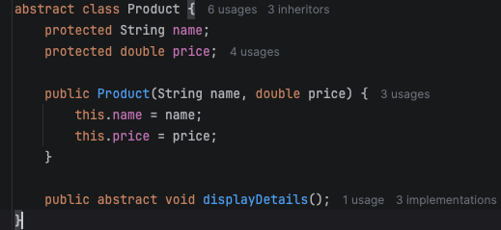
In the realm of object-oriented programing, there exists distinct types of classes. Among these include abstract classes. The main purpose of these classes is to serve as a “blueprint”. Though all classes are “blueprints”, what makes abstract classes different is that their methods do no work. We can see this in line 62 of our program (pictured in the screenshot below). In this line, we see an public abstract void method named displayDetails that includes no code within it – it’s just blank. According to GeeksForGeeks, “[a]n abstract method is a method declared without implementation (i.e., a body). This is exactly the abstract methods job – do serve as a blueprint but do no actual work (GeeksForGeeks, 2026).
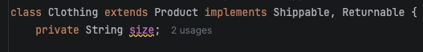
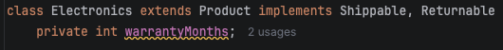
In “abstraction” (GeeksForGeeks, 2026), there not only exists abstract classes but there also exists interfaces. The job of an interface is to define an outline of behaviors that a class an implement, without actually saying exactly what the class is to do (GeeksForGeeks, 2026). The benefits of using these interfaces are that it allows us to share the same outline of behaviors to several different classes. This allows for multiple inheritance in Java – something not possible for classes (GeeksForGeeks, 2026). We can see this in lines 77 and 111 (line 77 is seen in the screenshot above).
Line 111 is seen on the right.
3. How did polymorphism simplify the main program?

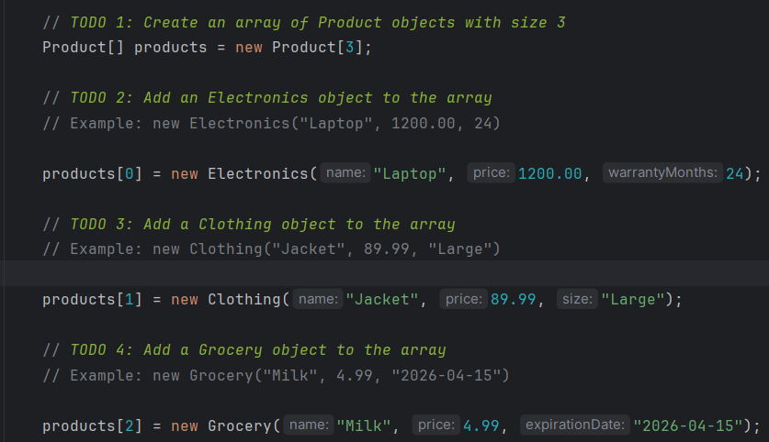The polymorphism simplified the main program by allowing us to have different instance of different subclasses to be a part of the Product array (via upcasting) and applying the given Product products in the array through method calls in the for loop 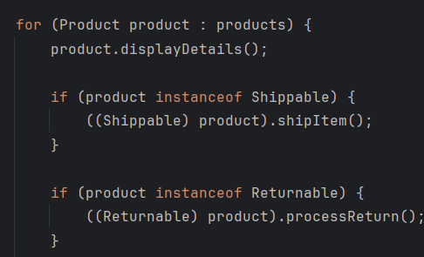 which allows for different classes/instances of to be reused and allow for different behaviors depending on the object, based from the snippet of the for loop.
4. Where was method overriding applied, and why was it important?

Method overriding was applied to this main class: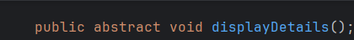
The following snippets of method Overriding were used: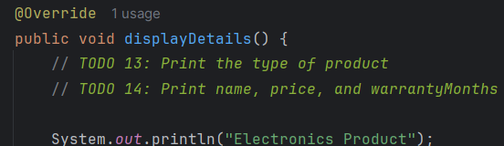 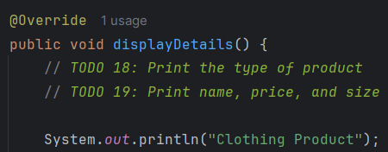 and 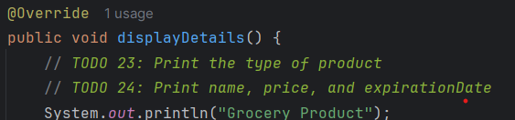 and this is important because this ensures that the program will display every product and their unique details rather than showing the same details repeatedly.

The class hierarchy presented in this program – specifically of the superclass Product and subclasses Electronics, Clothing, and Grocery – can undoubtedly be expanded to accommodate for a larger e-commerce system. To go about this, we would simply introduce more subclasses to accommodate for different products offered by the e-commerce site. This can include gardening products (such as fertilizers), office products (such as pens and printer paper), etc. Then, we would implement additional products objects to store each instance of the product that is made.

